Student’s Name
Professor’s Name
Course
August 30, 2020
Femininity and Masculinity Journal

Malik Zayn, Google Images
Link: https://www.google.com/url?sa=i&url=https%3A%2F%2Fwww.rockandpop.cl%2F2019%2F01%2Fzayn-malik-ex-one-direction-estrena-video-de-satisfaction%2F&psig=AOvVaw3054JzBSYJDx2fgnp5ONtj&ust=1598910430529000&source=images&cd=vfe&ved=0CA0QjhxqFwoTCJClzdvzw-sCFQAAAAAdAAAAABAF
The gender performance being described from the photo of Malik Zayne is his biological sex as a male. The image selected illustrates the male gender since it portrays masculinity alluding to the strong, serious, tough, handsome, rugged, brooding, edgy, profound, mysterious certainty, dark, and dangerous attributes. The traits align with Macey’s definition of a gendered male. Performing masculinity is highlighted in the image regarding how he is likely to break another person’s heart or Zayn’s ability to protect their loved ones from danger. From the Feminist Perspectives on Sex and Gender, Mackinnon reiterates, “ I may have been influenced to find male dominance as appealing” (101).
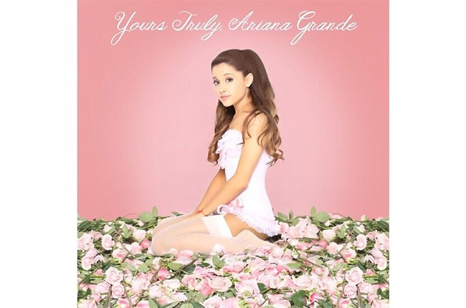
Grande, Ariana. “Yours Truly,” Album Cover, 2013
Link: https://www.google.com/url?sa=i&url=https%3A%2F%2Fwww.billboard.com%2Farticles%2Fcolumns%2Fpop-shop%2F5380950%2Fariana-grande-unveils-yours-truly-artwork-confirms-release-date&psig=AOvVaw1mnuNrUkH3D8JtQau4WT-P&ust=1598910616714000&source=images&cd=vfe&ved=0CA0QjhxqFwoTCJix3az0w-sCFQAAAAAdAAAAABAJ
Hyper-feminism is reflected in the image of Ariana Grande based on Macey’s definitions. Ariana has gender performance evidenced by the image to depict her feminine self through the possession of a sweet and beautiful face, which is perceived as ideal. The picture demonstrates the female gender based on Ariana’s beautiful complimented by her simple makeup, pink surroundings, and positioning on a flower bed. Her performing femininity is depicted from her dressing in a sexy manner while still maintaining a sexy look. She is a perfect embodiment of a young woman who strives for perfection but maintaining a non-aggressive and non-threatening self. She is portrayed as acting atypical gender role, which is analogous to her biological sex.
In addition, I am opined that my gender performance aligns with my sex. I have a female identity and do think otherwise about me being feminine. However, I strive to be more assertive to meet feminine idealism, one of my biggest aspirations. I believe in gender equality to reduce disparities that are always imminent in the contemporary world. I am convinced that an individual’s gender performance should be acceptable and conforms to cultural diversity requirements. My mother mostly influences my gender performance since she is the one who designed my lilac and pink-themed room. Even though I am twenty-one now, I have never felt the urge to change it to embrace gender neutrality or modernism. I am my parent’s “little” despite being an adult and all-grown now. I guess it is because I am their only child. Notably, I always feel that I have gained some maturity level, but I am always at dilemmas of going against their expectations since I live under their roof. I feel that when I become independent, I can become less traditionally-feminine though being comfortable now. Besides, I have lived in social environments that have influenced my perception of femininity. I conceive gender based on traditional thinking. I have minimal exposure to diverse gender performances; however, I am inclined towards broadening my ideology by getting out of my ideological comfort zones. My family has played an integral part in my determination of gender performance since I learned from them since everything I know about being a female. Macey articulates the conflicts that exist between race and gender, “I understand when a person’s actual physical body doesn’t match with the gender they’ve been born into. That is clearly very difficult to navigate” (Macey 84).
In conclusion, I selected the image of Malik Zayne to help elaborate on how he fosters gender performance in the context if a male. His traits align my perception of how males are or ought to be. Thus, I determined his positive and negative attributes based on my mental representation of males. I also chose Ariana Grande to reinforce the perception of feminism and female performance. The image was an ideal depiction of females in the modern world, alluding to their beautiful faces and perfect bodies embodied in their preference for specific colors. From a personal standpoint, I am opined that my gender performance is ideal with regards to my biological sex, which is female. I am always striving for feminine perfection since it is something I want to achieve. Culturally, I have tailored my gender performance to ensure that it is acceptable to all cultures. In doing so, I perceive myself as a culturally-inclusive person. My mother has played a significant role in molding my gender performance. I have been pampered throughout my life, so I have remained inclined to their personal perception of feminism. I am scared of ever going against their feminist ideals, but I am certain that I will be able to exercise gender performance autonomy once I become independent. I am not embarrassed that I envision gender from traditional perspectives, but I am open to exploring other gender ideas. The purpose of doing so is to have a wide knowledge of the same; therefore, enabling me to appraise my gender ideologies.

Works Cited
MacKinnon, S. Feminist Perspectives on Sex and Gender. Stanford Encyclopedia of Philosophy.
Sanford, California: University Press, 2006.
Macey, David. Penguin Dictionary of Critical Theory. Penguin: New York. 2000

